Basic Design and Technology
BECE 2020 — Paper 1 (Objective)
1. The appropriate instrument used for drawing circles on paper is a
A. pair of dividers.
B. pair of compasses.
C. protractor.
D. set square.
2. Which of the following methods of drawing is in two dimension?
A. Isometric.
B. Oblique.
C. Orthographic.
D. Perspective.
3. In designing and making, the stage where useful information is produced in two dimension?
A. analysis.
B. investigation.
C. situation.
D. specification.
4. An electronic component which indicates that current is flowing in a circuit is
A. capacitor.
B. diode.
C. LED.
D. indicator.
Figure 1 shows the pictorial view of a block. Use it to answer questions 5 and 6.
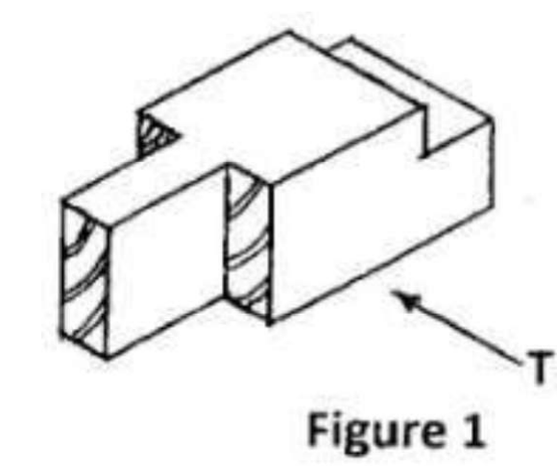
5. Which of the following represents the front view in the direction of arrow T?
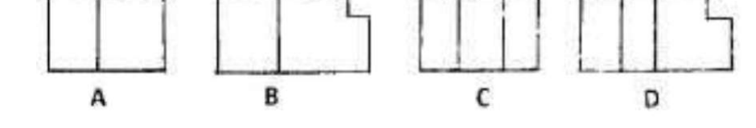
6. The correct plan, viewing from the top, is
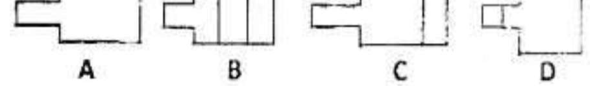
7. When laying a table for a customer, the fork is placed
A. in front of the plate.
B. at the right side of the plate.
C. across the plate.
D. at the left side of the plate.
8. A French seam is the most appropriate seam for
A. children's wear.
B. heavy weight fabric.
C. light weight fabric.
D. undergarments.
9. In order to retain the nutrients in leafy vegetables
A. cut one hour before cooking.
B. cut when ready to cook.
C. cut when the water is boiling.
D. cut few minutes before cooking.
10. Food is preserved mainly to
A. maintain its nutrients.
B. make it last longer.
C. make it palatable.
D. protect micro-organisms in food.
11. On the 6-point colour wheel, blue is next to
A. green.
B. orange.
C. yellow.
D. red.
12. Identify the pair that are principles of design.
A. Variety and rhythm.
B. Balance and colour.
C. Repetition and dots.
D. Contrast and shape.
13. The colour violet symbolizes
A. wealth.
B. peace.
C. aggression.
D. royalty.
14. The inscription BB on a pencil indicates that it
A. is hard.
B. is soft.
C. breaks easily.
D. sharpens well.
15. Which of the following depends on the principles of perspective in drawing?
A. Balance.
B. Foreshortening.
C. Repetition.
D. Rhythm.
16. An important factor to consider when selecting an opening for a garment is the
A. style of garment.
B. the type of fabric.
C. length of fastening.
D. colour of fastening.
17. Covering puddings with grease proof paper when steaming is to
A. make it cook quickly.
B. prevent it from sinking.
C. prevent water from entering.
D. make it rise quickly.
18. A characteristic of animal fibre is that they
A. melt at high temperature.
B. have low absorption power.
C. have high absorption power.
D. are good conductors of heat.
19. An appliqué patch is most often used on
A. girl's uniform.
B. men's shirt.
C. pair of trousers.
D. children's cotton blouse.
20. Buttons and loops are best used on the back neck edge silt of
A. school uniforms for girls.
B. nurses uniform.
C. baby's dresses.
D. blouse for the aged.
21. Dish cloths are used in the kitchen for
A. wiping working tables and boards.
B. wiping glassware and cutlery.
C. removing dishes from oven.
D. lining the ingredient tray.
22. Select the dry methods of cooking from the following
A. braising and baking.
B. stewing and roasting.
C. braising and stewing.
D. roasting and baking.
23. To transfer pattern markings from paper pattern onto fabric, use
A. tailor's tacks.
B. basting.
C. tacking.
D. even tacking.
24. A suitable temporary stitch used to hold down interfacing of a round collar is
A. even tacking.
B. long and short tacking.
C. diagonal tacking.
D. tailors tacking.
25. Which of the following vitamins can easily be destroyed by heat?
A. Vitamin A.
B. Vitamin B.
C. Vitamin D.
D. Vitamin K.
26. Table linen include
A. cloths and napkins.
B. crockery and table runners.
C. table cloth and cutlery.
D. tablemats and glassware.
27. A change in colour of a peeled banana left in the open is due to
A. yeast activities.
B. presence of fungi.
C. fermentation.
D. oxidation.
28. When frying meat, heat is transferred by means of
A. radiation.
B. conduction and convection.
C. radiation and convection.
D. conduction.
29. Which of the following is a white fish?
A. Mackerel.
B. Cod.
C. Herring.
D. Tilapia.
30. A meal eaten between breakfast and lunch is
A. high tea.
B. snack.
C. supper.
D. confectionery.

Answer Key
1. B pair of compasses  2. C Orthographic  3. D specification  4. C LED  5. B (see diagram, option B)  6. C (see diagram, option C)  7. D at the left side of the plate  8. C light weight fabric  9. B cut when ready to cook  10. B make it last longer  11. A green  12. A Variety and rhythm  13. D royalty  14. B is soft  15. B Foreshortening | 16. A style of garment  17. C prevent water from entering  18. C have high absorption power  19. D children's cotton blouse  20. A school uniforms for girls  21. A wiping working tables and boards  22. D roasting and baking  23. A tailor's tacks  24. C diagonal tacking  25. B Vitamin B  26. A cloths and napkins  27. D oxidation  28. D conduction  29. B Cod  30. B snack

